**EQ Module Description Document**

**1.Introduction**

The AP80 series chips integrate a hardware-accelerated EQ module, which consists of a cascade of five 3rd-order IIR filter stages for audio effect adjustment. At the same time, the software development driver library also provides a software EQ API. Therefore, there are three forms of EQ available for use: hardware EQ, software EQ, and hybrid EQ.

The mathematical expression of the IIR filter that constitutes the EQ is as follows:

IMG_256(Z Domain)

IMG_256(Time Domain)

Users can use the tool ACPWorkbench provided by Shanjing to design EQ frequency response curves. The following POP EQ is the effect diagram of three third-order IIR filters cascaded.

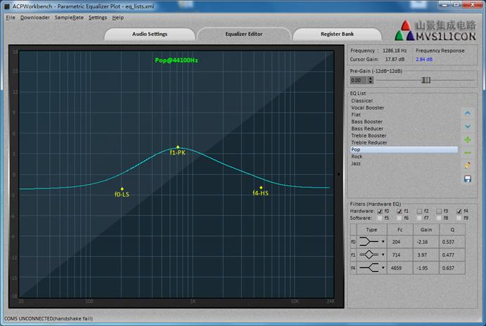

Figure 1. EQ Frequency Response Curve

**2.Main Features**

* Supports 5-level 3rd-order IIR hardware EQ
* Supports 10-level 3rd-order IIR software EQ
* Supports 5-level 3rd-order IIR hardware EQ + 5-level 3rd-order IIR software EQ

**3.Instructions for Use**

**3.1. Hardware EQ Application**

1. Prepare the EQ parameters using the auxiliary tool [[1]](#NUM1).

2. Configure the EQ parameters to the register by calling the EqStyleConfigure() function.

1. Start the hardware EQ.

**3.2. Software EQ Application**

1. Prepare EQ parameters using auxiliary tools.

2. Initialize the software EQ by calling the SwEqInit() function.

3. Configure EQ parameters to the software EQ structure by calling the SwEqStyleConfigure() function.

4. Process each frame of PCM data to be played by calling the SwEqApply function.

**3.3. Hybrid EQ Application**

Combines the use of hardware EQ and software EQ.

**3.4. Precautions**

Switching EQ may produce popping sounds. The main reason is that the EQ is still active during the parameter switch, so the combination of old and new EQ parameters may result in sudden changes in the data.

1. For general EQ sound effect switching, you can first disable EQ, then configure the EQ parameters, and finally enable EQ.
2. For simple bass/treble sound effect gain adjustment, you don't need to turn off EQ. Instead, you can gradually adjust the EQ gain value from the old gain value to the new gain value in N (N is about 10) steps.

[[1]](#【1】) ACPWorkbench: <http://192.168.1.142:8080/redmine/issues/1749>